## 

SWE 600

Advance Software Engineering Project

**Click-And-Collect**

## 

## 

Project Supervisor - Prof.Qamar Asghar

|  |  |
| --- | --- |
| **Name** | **Student ID** |
| Nauka Shah | 24083814 |
| Aditi Parikh | 95991 |
| Yunfeiyue Liu | 92636 |
| Ayesha Taqdees | 90366 |

**Table Of Contents**

**Project Concept** **4**

**Vision Document** **4**

**Revision History** **5**

**Project Plan** **6**

**Project Schedule** **6**

**Meeting Minutes** **7**

**Lessons Learned** **7**

**Requirements Overview** **8**

Functional Requirements 8

Non-Functional Requirements 8

Reliability Requirements 10

Reliability requirements specification 10

Type of application 11

Non-critical application 11

Reliability metrics 11

Key concerns 11

How system works: 11

**Risk Assessment** **12**

**Software Architecture** **15**

API Endpoints 16

**Database Architecture** **17**

Table relations 18

**Security Components in Design** **19**

Data Security and encryption: 20

**Use Case Diagrams** **24**

Use Case Details 25

**UML Activity Diagrams** **35**

**UML Sequence Diagrams** **36**

**UML Collaboration Diagrams** **37**

**UML Class diagram** **38**

**UML State Diagram** **39**

**System Component Diagram** **40**

**System Design Overview** **41**

**Quality Test and Plan** **42**

**End user Training** **48**

**References** **49**

**Project Glossary** **50**

# Project Concept

While online shopping is convenient, in-store pickup allows consumers to place an order from online, avoid shipping costs and get their item in minutes without working through the store. But Many times consumers have to queue behind other shoppers when they arrive in-store to pick up the order, before being called over the PA system once their order is ready. With beacons, brands can now use geofencing to keep a customer’s order ready just before they arrive when they opt for in-store pickup.

Works as a smart Reminder if Customer is passing through the store without picking up the online ordered stuff and provides an option for him to click and collect.

# Vision Document

Beacons, When placed in a physical space, such as a retail store, they broadcast radio signals around themselves (like a tiny lighthouse) and with very low power consumption so they can be left for many years. As they broadcast they are able to interact with smartphone Apps that enter their field of range.We are focused to use this technology to create a “frictionless” collection notification system for customers & stores. The solution identifies collection customers with Beacons & checks their order status. If their goods are ready to collect the customer receives a custom notification on their smartphone asking them if they would like to collect it.

So, While passing from the store, The beacon attached to the entrance of the store, identifies the customer and his order to be collected, Beacon notifies the in-store system and the system sends one push notification to that customer,if he would like to collect his order. When the customer replies with yes, The response is recorded back to the in-store system and in-store staff will start preparing the order. On completion of the order, the customer will receive a confirmation notification with the details of the pickup location in the store. We can use this technology for in-store digital shopping as well. Where, Customers can add the items to his cart in the app, while he roams into the store and sees the items. Without lifting or shopping actually. On completion of the virtual shopping, He may select the Click-to collect service for his order. The in-store staff gets notified and receives his order and the beacon confirms the presence of the customer physically, that order will be prepared on priority basis. While his order is being ready, the customer may go to any other store and do virtual shopping..! It will be great for all the window shoppers.

**Benefits**

* Around 90 meters of radius and transmission
* Internet is not needed
* Only shoppers with Click or Reserve & Collect orders ready for them to collect in that store receive alerts triggered by Beacons
* With no need for manned service desks or counters, the collection service is open as long as your store is without extra staff costs
* As shoppers mobile phones instigate & control collections there’s no retailer cost to operate the service regardless of customer volume
* Deliver digital content and interactions with customers based on store movements and precise locations, in real-time
* Fast, effortless collection check-in gives customers time & freedom to browse & buy in store & be receptive to offers & promotions
* Staff & Mgt have access to live collection data including in store customer levels & service times

**Target users**

* Retail Stores
* Shoppers with iOS/iPadOS device
* Application will generate list of orders fetched from the store APIs
* User will be notified if he is in range of the store.
* User will be notified if an order is in process.
* User will be notified when order is ready to pick up.
* Application will have the option to click and collect.
* User will get confirmation of order completion and order details.
* User will be able to see Order history.

# Revision History

|  |  |
| --- | --- |
| Revision | Date |
| SWE Report V1 | 03/24 |
| SWE Report V2 | 03/27 |

# 

# 

# Project Plan

# Project SchedulePoints scored

# 

# Meeting Minutes

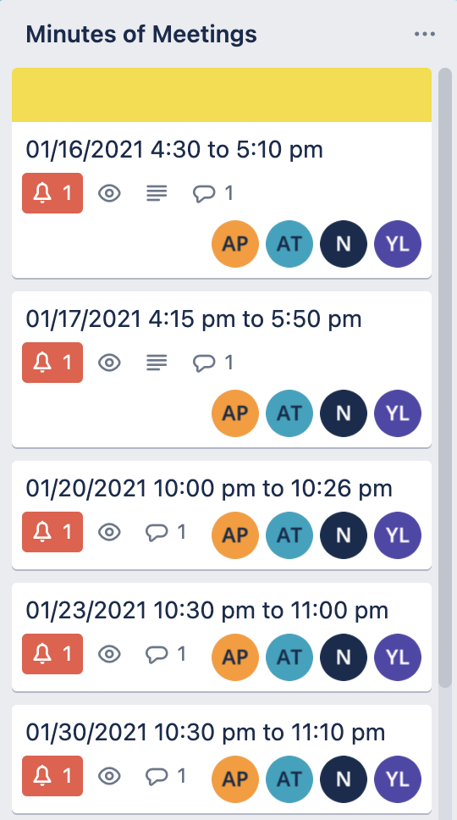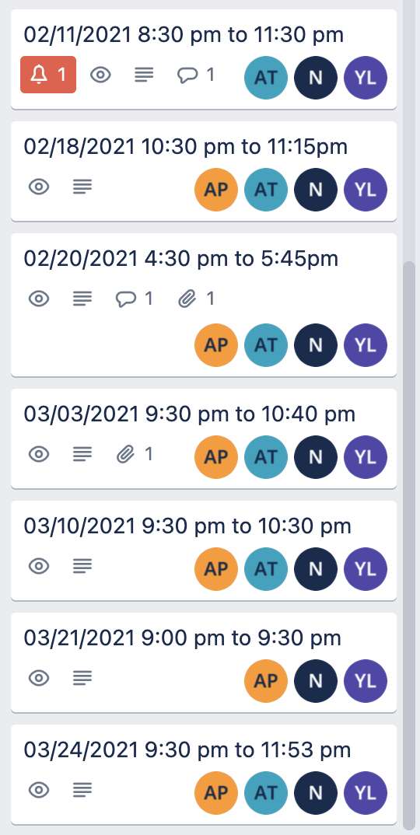

# Lessons Learned

* First understand the existing code.
* Teamwork
* Leadership experience
* Risk analysis
* UML Diagrams
* The non-technical problems are the most difficult
* What you create is more important than the tools used to create it
* Every role is equally important
* Never Assume
* Start Small
* Have an Estimated Project Length? Double it.
* Understand the Code Before Changing It
* Develop an Error Handling Landscape
* Bugs are Unavoidable
* Seek Help When You Can’t Cope on Your Own
* Keep on Learning

# Requirements Overview

## Functional Requirements

1. The Application shall have login and logout functionality.
2. App shall fetch order details from the store APIs.
3. App should generate a list of orders.
4. Users will be able to see the list of open orders in the app.
5. App should be able to communicate with the beacons in the store if the user is in the range.
6. App should notify the user if he is in the range of 90 meters from the store where he placed the order(example:You are near the store).
7. Apps should notify the User if an order is in process.
8. Users should be able to see in the updated status of the order in the app.
9. Application should notify the User if an order is ready for pickup.
10. Application shall have the option to click and collect.
11. Store will get notified if the user is ready to collect the order.
12. Users should be able to see in the app that the order is ready for pick up.
13. The user should get the confirmation of order completion and order details.
14. Users will be able to see the list of completed orders in the app.

## Non-Functional Requirements

1. Response time of the application should be between two and five seconds
2. System should have strong Authentication (Security)
3. Service should be up and running all the time (Availability)
4. System should be scalable (The highest workloads under which the system will still meet the performance requirements) (Scalability)
5. System has to be reliable which means the system would run without a failure for a given period of time under predefined conditions. (Reliability)

## 

## Reliability Requirements

|  |  |
| --- | --- |
| **Requirement** | **Failure** |
| Fetch order details using store APIs | User won’t be able to see orders in our app |
| Beacon Failure | Beacon listening will fail and user won’t be notified for the order status |
| Cell Phone switched-off | Human error - beacon communication failure |
| Database connection loss | System will not create entries for the orders with the order id, merchant name, beacon id and order status |

### Reliability requirements specification

1. Fetch order details using store APIs   
   Failure: user won’t be able to see orders in our app
2. Beacon failure   
   Failure: Beacon listening will fail and user won’t be notified for the order status
3. Cell Phone switched-off   
   Failure: Human error- beacons communication failure
4. Database connection loss   
   Failure: System will not create entries for the orders with the order id, merchant name, beacon id and order status

### Type of application

### Non-critical application

### Reliability metrics

* Rate of occurrence of failure (ROCOF)

### Key concerns

* To ensure that the app is up and running to communicate with the beacons when needed and that they properly record order details in account database
* This metric is relevant as the application has to process large numbers of requests at same time

### How system works:

* Users downloads and installs the app.
* Users will sign up for an account using an email.
* App will request access to users' email.
* System will scan all the emails with the keywords like “order number” and “pickup to find pickup orders.
* System will create entries for the orders with the order id, merchant name, beacon id and order status.
* The App using the phone's ibeacon will constantly scan the environment for BLE devices such as beacons.([iBeacon](https://developer.apple.com/ibeacon/) is a new location technology that lets any phone using iOS7 or newer constantly scan the environment for BLE devices such as beacons). Ref: [https://developer.apple.com/ibeacon](https://developer.apple.com/ibeacon/)
* When a user's phone is in the range of the beacon in the store, the phone will detect the beacon and get the beacon id.
* The system will query the database to find if there are any open orders associated with the beacon id.
* If there are any open orders, the system will send the notification to the beacon in the store using the phone SDK.

# Risk Assessment

|  |  |  |  |  |  |  |  |
| --- | --- | --- | --- | --- | --- | --- | --- |
| **Index** | **Risk Summary** | **Risk Category** | **Probability**  **(In %)** | **Cost (Loss in Days)** | **Risk Exposure** | **Impact (1-4)** | **RMMM** |
| 1 | Insufficient Financial support. | Business Impact | 50 | 40 | 20 | 3 | - During project planning, fixed budget should be agreed by all stakeholders and allocated to the project prior to the development  - In case of Funding lost during the project work, Team along with the stakeholders can search for the alternative resources/tools/technologies that can be less expensive than the previous ones but still serves the purpose |
| 2 | Change of Requirements | Process definition | 50 | 20 | 10 | 2 | - Meet with customer and finalize and freeze the requirements before starting the project work  - Have a documentation of all the requirements and get them approved from customer to minimize ambiguity  - Conduct timely review or delivery and meetings with customer so that we can track the accurate progress over correct system |
| 3 | Unplanned work that must be accommodated | Process definition | 40 | 15 | 6 | 1 | - Plan in advance and have buffer time for all unexpected changes  - Escalate to the Project Manager with a plan of action, including impact on time, cost and quality. |
| 4 | Deadline change | Business Impact | 40 | 15 | 6 | 3 | - Add extra resources to the team  - All stakeholders should meet and agree upon which are the critical or main functionalities need to be delivered on first release. all addon features can be released with new version of the system gradually |
| 5 | Lack of Hardwares - Beacons or Softwares and proper tools or technology. | Technology to be built | 40 | 15 | 6 | 3 | - All required resources of tools/technology/hardware or softwares should be listed while planning  - In case of lack of any resources during the development, Team can raise the requirement of the resources and shift or switch the priorities of the tasks while they arrive |
| 6 | Insufficient QA time to validate on all Features | Staff size and experience | 45 | 7 | 3.15 | 3 | - Plan well and have buffer time for QA and Regression cycle  - Add extra QA resource to the team to chase the deadline with QA approved system |
| 7 | Staff turnover | Staff size and experience | 30 | 8 | 2.4 | 3 | - Meet with current staff to determine causes of turnover  - Mitigate those causes that are under our control before the project starts  - Organize project teams so that information about each development activity is widely dispersed  - Define documentation standards and establish mechanisms to ensure that documents are developed in a timely manner  - Assign a backup staff member for every critical technologist |
| 8 | Larger number of Users than expected. Loads increase risk. | Customer characteristics | 30 | 8 | 2.4 | 4 | - Meet with customer and understand the end user's usage pattern  - Have backup database or system ready in case of load increase  - Load testing should be performed by QA before the release to customer |
| 9 | Stakeholder action delays project. | Customer characteristics | 20 | 10 | 2 | 2 | - Identify stakeholders, analyse power and influence and create a stakeholder engagement plan  - Revisit the plan at regular intervals to check all stakeholders are managed |
| 10 | Lack of verifiable sample data may affect the ability of the primary external stakeholder to validate end product. | Customer characteristics | 40 | 5 | 2 | 2 | - Meet with QA team and prepare the document for all sample data with which they have test and the result and share that document with customer |
| 11 | Responsive Design issues and risk | Process definition | 30 | 6 | 1.8 | 3 | - Have clarity upon the devices for which the system needs to be used by end users  - Team should aware about the latest devices OS and Versions and practice the standard design implementation |
| 12 | Insufficient knowledge of Technical Skills or New technology | Technology to be built | 20 | 6 | 1.2 | 2 | - Technology training session should be scheduled for all who will be working for the system  - In case of any critical roadblock issue, Organization may reach or consult the technical expert outside of the company |
| 13 | Following end-user testing, more effort on the user guide may be necessary. | Process definition | 15 | 6 | 0.9 | 2 | - User guide/Manual creation should be added and considered as a task before the release  - After QA system testing, BA or QA can work on preparing the document  - In iterative releases, User guide can be populated on each release and customer's feedback should be recorded |
| 14 | Insufficient time for external stakeholders to submit feedback on system | Customer characteristics | 10 | 5 | 0.5 | 1 | - Share the whole schedule with the External stakeholders including the dates by which their feedback is expected  - In case of delay, Team can work on the prior unresolved conflicts or changes which will not affect the release |
| 15 | Backup and restore of Database | Development environment | 10 | 3 | 0.3 | 1 | - Project planning should take all the scenarios into consideration including the data lost or database overload or server down  - Backup and restore functions should be planned in timely manner without affecting the current working of the system |

# 

# 

# Software Architecture

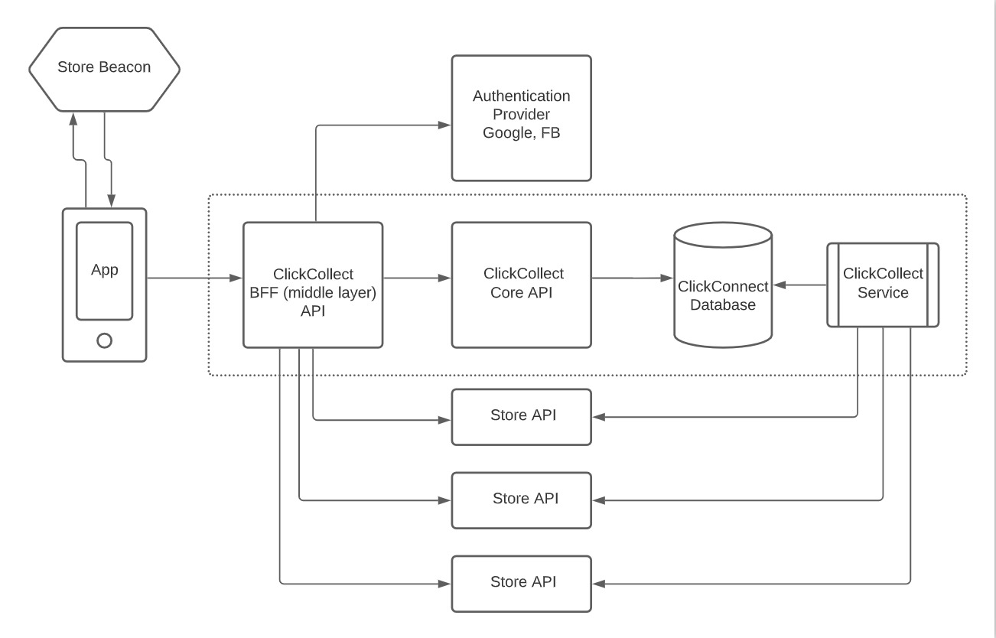

## API Endpoints

# 

# 

# 

# 

# 

# 

# 

# 

# 

# 

# Database Architecture

# 

### 

### Table relations

# 

# 

# 

# Security Components in Design

Security mechanisms when a user is accessing an application:



### **Data Security and encryption:**

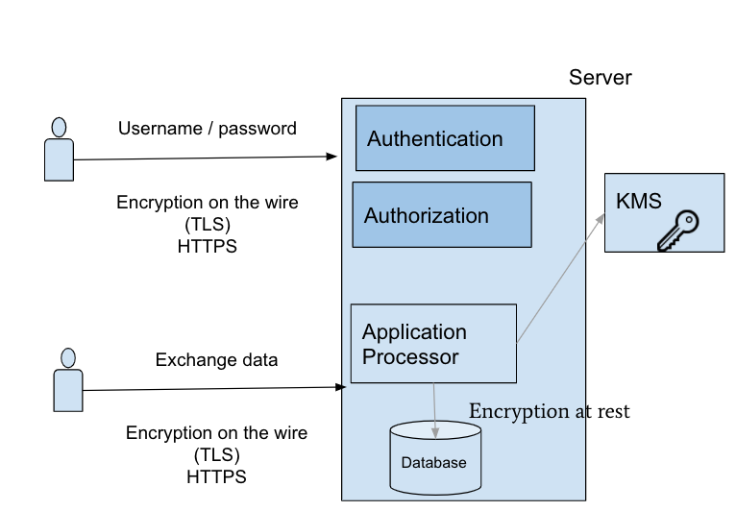

Encryption on the wire is the process of protecting sensitive data while being sent from one source over the network or the internet to another source.

Encryption at rest is the process of encrypting hard drives or files to prevent unauthorized access.

With HTTPS, data is encrypted in transit in both directions: going to and coming from the origin server. The protocol keeps communications secure so that malicious parties can't observe what data is being sent. As a result usernames and passwords can't be stolen in transit when users enter them into a form. If our application has to send sensitive or personal data to users, encryption protects that data.

When the browser connects to an HTTPS server, the server will answer with its certificate. The browser checks if the certificate is valid:

1. the owner information needs to match the server name that the user requested
2. the certificate needs to be signed by a trusted certification authority

If one of these conditions is not met, the user is informed about the problem.

Once the HTTPS handshake is complete all communications between the client and the server are encrypted. This includes the full URL, data (plain text or binary), cookies, and other headers.

The only part of the communication not encrypted is what domain or host the client requested a connection. This is because when the connection is initiated an HTTP request is made to the target server to create the secure connection. Once HTTPS is established the full URL is used.

1. **Authentication**

Principal authentication is the process of proving user identity to the security enforcing components of the system so that they can grant access to information and services based on who you are. This applies to both human users of the system as well as to applications. A user or application that can authenticate itself is known as a principal. A principal has a name that uniquely identifies it. In order to successfully authenticate to the system, it is important that a principal can provide some proof that it is who it claims to be. Proof of authentication is usually achieved by a password or cryptographic key.

1. **Authorization**

Role-based access control (RBAC) refers to the idea of assigning permissions to users based on their role within an organization. It offers a simple, manageable approach to access management that is less prone to error than assigning permissions to users individually. Users must be authenticated (logged in) before his/her request can be authorized (granted permission to access). Authorization configuration is done by granting/revoking roles to/from users. These APIs use IDs for stores, and roles.

Authorization Configuration REST API allows to:

* Get the users by role
* Grant a role to a user
* Revoke a role from a user

If any authorizer approves or denies a request, that decision is immediately returned and no other authorizer is consulted. If all modules have no opinion on the request, then the request is denied. A deny returns an HTTP status code 403.

1. **Mutual TLS Authentication**

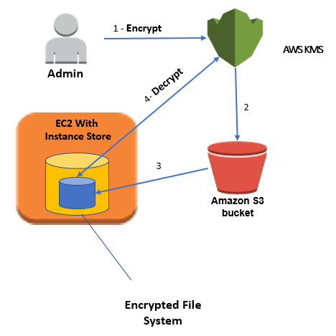

There are three states in which data exists in mobile apps:

1. Data at rest is mobile app data that is persistent and stored in the application sandbox.
2. Data in transit is mobile app data sent from the app to outside servers or other app users.
3. Data in use (aka data in memory) is data the mobile app temporarily stores in application memory, including Data at rest and in transit before they are sent/saved. Data at rest and Data in use encryption are enabled as part of TOTALData Encryption. AWS Key Management System ensures that Data in transit is encrypted and protected.

Encryption at rest provides data protection for stored data (at rest). Attacks against data-at-rest include attempts to obtain physical access to the hardware on which the data is stored, and then compromise the contained data. In such an attack, a server's hard drive may have been mishandled during maintenance allowing an attacker to remove the hard drive. Later the attacker would put the hard drive into a computer under their control to attempt to access the data.

Mutual TLS (mTLS) authentication ensures that traffic is both secure and trusted in both directions between a client and server. It allows requests that do not log in with an identity provider (like IoT devices) to demonstrate that they can reach a given resource.

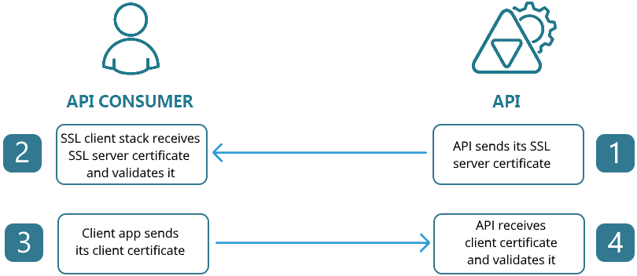

Encryption is the secure encoding of data used to protect the confidentiality of data. The Encryption at Rest designs in Azure use symmetric encryption to encrypt and decrypt large amounts of data quickly according to a simple conceptual model:

* The symmetric encryption key is used to encrypt data as it is written to storage.
* The same encryption key is used to decrypt that data as it is readied for use in memory.
* Data may be partitioned, and different keys may be used for each partition.
* Keys must be stored in a secure location with identity-based access control and audit policies.

## 

# Use Case Diagrams

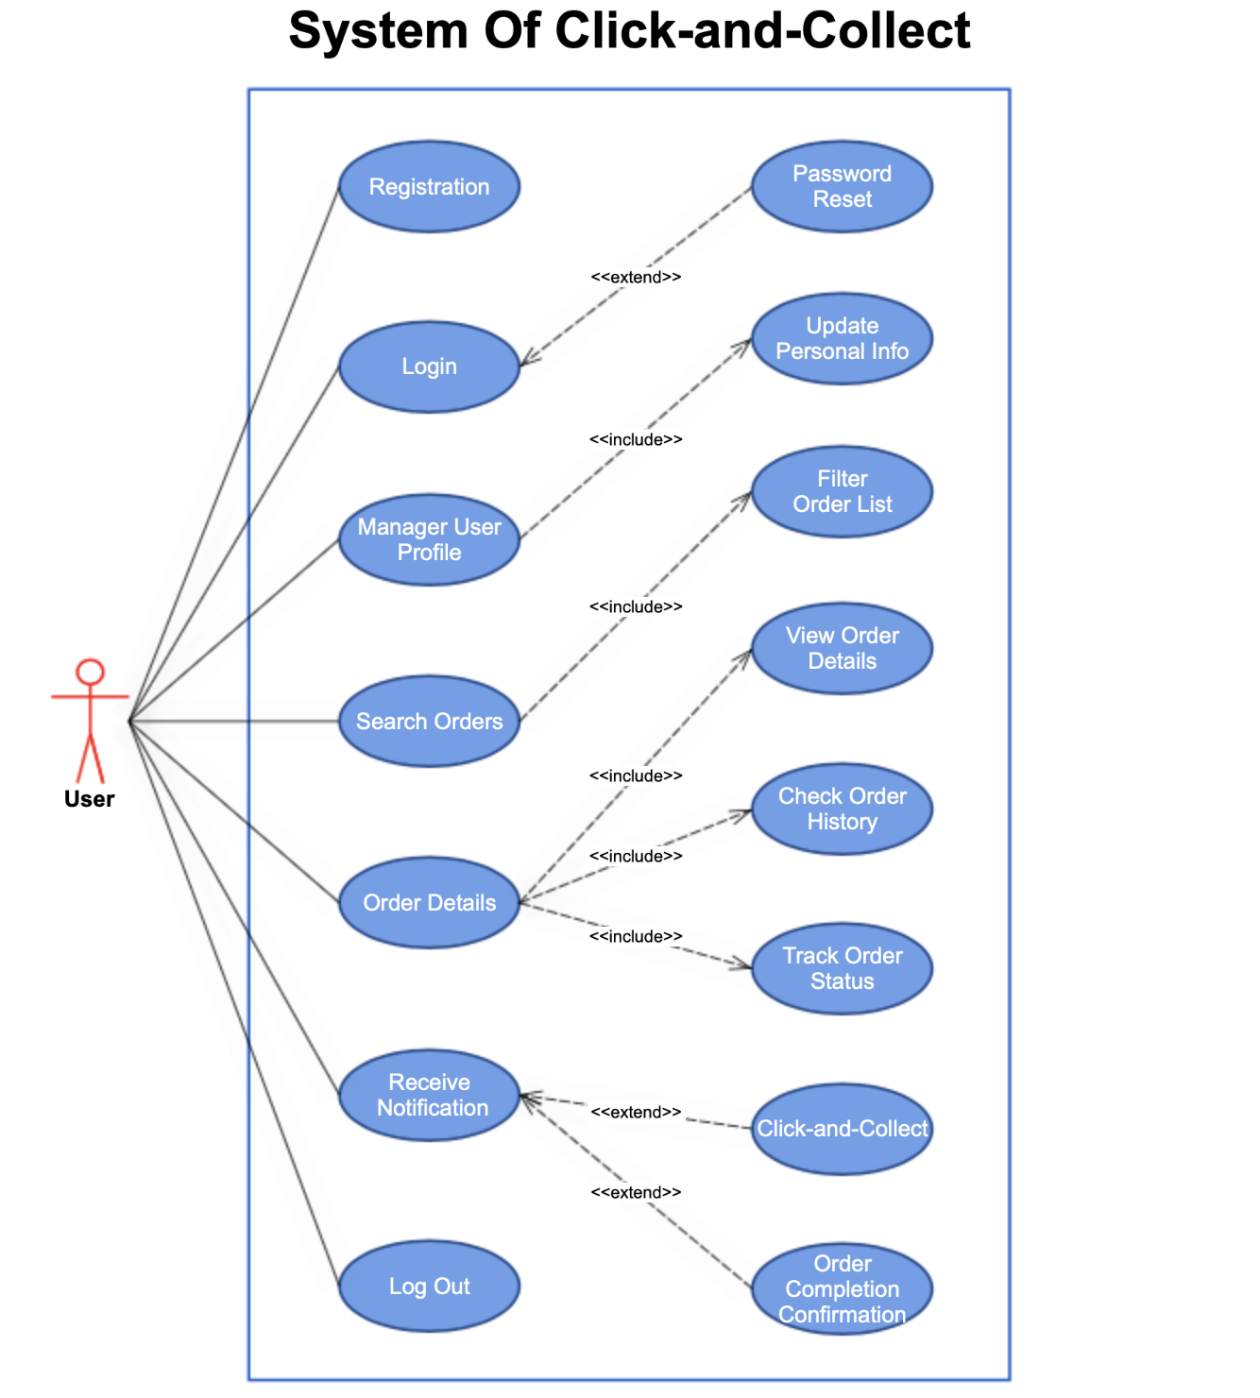

## 

## Use Case Details

Use Cases 1. Registration

|  |  |  |
| --- | --- | --- |
| **Use Case Name** | **Registration** | |
| **Description** | A user registers for an account for the system to access the functionality of the system | |
| **Actors** | Customers | |
| **Pre-Condition** | System must be connected to the network | |
| **Post-Condition** | After a successful registration, a confirmation email is sent to the user’s email address | |
| **Main Scenarios** | **Serial No.** | **Steps** |
| **Actors/Users** | 1 | Enter Email Address  Enter Password |
|  | 2 | Validate Email Address and Password |
|  | 3 | Allow access to the system |
| **Exceptions** | a | Invalid email address format  System shows an error message |
|  | b | Input password doesn't meet the system requirement  System shows an error message |
|  | b | The email address already exists  System notifies the user that the email address exists and redirects the user to login instead. |

Use Cases 2. Login

|  |  |  |
| --- | --- | --- |
| **Use Case Name** | **Login** | |
| **Description** | A user login to the system to access the functionality of the system | |
| **Actors** | Customers | |
| **Pre-Condition** | System must be connected to the network | |
| **Post-Condition** | After a successful login, the user will be redirected to the Order screen. | |
| **Main Scenarios** | **Serial No.** | **Steps** |
| **Actors/Users** | 1 | Enter Email Address  Enter Password |
|  | 2 | Validates Email Address and Password |
|  | 3 | Allow access to the system |
| **Exceptions** | a | Invalid email address  System shows an error message |
|  | b | Invalid password  System shows an error message |
|  | c | Invalid password for 4 times  System shows an error message and give options for **Password Reset** |

Use Cases 3. Password Reset

|  |  |  |
| --- | --- | --- |
| **Use Case Name** | **Password Reset** | |
| **Description** | A user can request to reset password when forgetting the previous login password | |
| **Actors** | Customers | |
| **Pre-Condition** | System must be connected to the network | |
| **Post-Condition** | After a successful password reset, a confirmation email is sent to the user’s email address. | |
| **Main Scenarios** | **Serial No.** | **Steps** |
| **Actors/Users** | 1 | The user enters the email address and clicks on the password reset button to request a password reset. |
|  | 2 | The system sends an email to the target email address with the password reset link included. |
|  | 3 | The user clicks on the link which leads to a webpage where the user can enter a new password. |
|  | 4 | The user clicks on the save button to save the new password. |
| **Exceptions** | a | Email address doesn’t exist  System shows an error message |
|  | b | Input password doesn't meet the system requirement  System shows an error message |

Use Cases 4. Manage User Profile

|  |  |  |
| --- | --- | --- |
| **Use Case Name** | **Manage User Profile** | |
| **Description** | A user can view and update his user profile in the system | |
| **Actors** | Customers | |
| **Pre-Condition** | The user must have logged in. | |
| **Post-Condition** | An email notification will be sent to the user’s email address regarding to any change of the user profile. | |
| **Main Scenarios** | **Serial No.** | **Steps** |
| **Actors/Users** | 1 | The user can review the existing profile including email address,  user name(optional), address(optional), profile photo(optional). |
|  | 2 | The user can also **Update Personal Info****.** |

Use Cases 5. Update Personal Info

|  |  |  |
| --- | --- | --- |
| **Use Case Name** | **Update Personal Info** | |
| **Description** | A user can update his personal info in the system | |
| **Actors** | Customers | |
| **Pre-Condition** | The user must have logged in. | |
| **Post-Condition** | An email notification will be sent to the user’s email address regarding any change of the user profile. | |
| **Main Scenarios** | **Serial No.** | **Steps** |
| **Actors/Users** | 1 | The user can click on the update button and make changes to contents of the user name, address and profile photos in the personal profile page. |
|  | 2 | Click the save button and the personal information is updated. |
| **Exceptions** | a | Attempt to change the email address  System shows an error message that the email address cannot be modified. |

Use Cases 6. Search Orders

|  |  |  |
| --- | --- | --- |
| **Use Case Name** | **Search Orders** | |
| **Description** | A user can search the orders | |
| **Actors** | Customers | |
| **Pre-Condition** | The user must have logged in. | |
| **Post-Condition** | The search is completed and a list of search results will be shown at the same page. | |
| **Main Scenarios** | **Serial No.** | **Steps** |
| **Actors/Users** | 1 | The user navigates to the Orders screen through the navigation bar. |
|  | 2 | The user enters the search key words in the text field and clicks on the “Search” button to conduct search. |
|  | 3 | A list of matching orders will be shown at the same page which includes order number, order store, order date, order status. |
|  | 4 | The user can filter the orders though **Filter Order List**. |
| **Exceptions** | a | No record matches the search key word  System shows a message indicating no record found. |
|  | b | Search time exceed the maximum search time  System shows a message which suggests the user to filter the order first before searching to speed up the search. |

Use Cases 7. Filter Order List

|  |  |  |
| --- | --- | --- |
| **Use Case Name** | **Filter Order List** | |
| **Description** | A user can filter the orders or search results to narrow down the target lists. | |
| **Actors** | Customers | |
| **Pre-Condition** | The user must have logged in and at the Orders screen. | |
| **Post-Condition** | The filter has been applied to the search results which are shown as a list. | |
| **Main Scenarios** | **Serial No.** | **Steps** |
| **Actors/Users** | 1 | The user checks no more than 3 matching options from the dropdown list of “Store” |
|  | 2 | The user checks no more than 3 matching options from the dropdown list (Closed Orders, Inactive Open Orders, Order In Progress, Ready to Pickup) of “Order Status” |
|  | 3 | The user clicks on the “Apply” button to apply the filters to the search results. |
|  | 4 | A list of matching orders will be shown at the same page which includes order number, order store, order date, order status. |
|  | 5 | The user can click “Clear” to clear all checked filters. |
| **Exceptions** | a | Attempt to choose more than 3 options in each filter category  The checkbox greyed out after having 3 options selected. |

Use Cases 8. View Order Details

|  |  |  |
| --- | --- | --- |
| **Use Case Name** | **View Order Details** | |
| **Description** | A user can view order details after clicking on the order number. | |
| **Actor** | Customers | |
| **Pre-Condition** | The user must have logged in and at the Orders page. | |
| **Post-Condition** | The page of order detail is successfully loaded and it contains correct detail information associated with the order number. | |
| **Main Scenarios** | **Serial No.** | **Steps** |
| **Actors/Users** | 1 | The user clicks on the order number |
|  | 2 | The system redirects the user to a new page where it shows all detailed information associated with the order. |
|  | 4 | The user can view the order details including order number, order store, items in the order, order status, order date. |

Use Cases 9. Receive Notification

|  |  |  |
| --- | --- | --- |
| **Use Case Name** | **Receive Notification** | |
| **Description** | A user can receive notification when there is a change of order status or there is a store associate with open orders in range. | |
| **Actors** | Customers | |
| **Pre-Condition** | The user must have logged in with notification service enabled. | |
| **Post-Condition** | A notification will appear on the user’s phone regarding any change of an open order status or when there is a store associate with open orders in the range. | |
| **Main Scenarios** | **Serial No.** | **Steps** |
| **Actors/Users** | 1 | A pop-up alert will inform the user that there is a status change in an order with order number listed. |
|  | 2 | The user is given options to view or ignore the alert. |
|  | 3 | The user will be redirected to **Track Order Status** if the button “View” is clicked. |
|  | 4 | The user will stay at the same page if the button “Ignore” is clicked. |
| **Alternative Scenarios** | **Serial No.** | **Steps** |
|  | 1 | A pop-up alert will inform the user that there is a store nearby with open orders available for pickup. |
|  | 2 | The user has options to pick up the order or to ignore the alert. |
|  | 3 | The user is redirected to the **Click-and-Collect**page if the button “View” is clicked. |
|  | 4 | The user will stay at the same page if the button “Ignore” is clicked. |

### 

Use Cases 10. Click-and-Collect

|  |  |  |
| --- | --- | --- |
| **Use Case Name** | **Click-and-Collect** | |
| **Description** | A user can confirm the pickup of an existing open order from a nearby store. | |
| **Actors** | Customers | |
| **Pre-Condition** | The user must have logged in and within the range of the store beacon. | |
| **Post-Condition** | A collect request is successfully sent to the nearby store and the user can track the order status through the app. | |
| **Main Scenarios** | **Serial No.** | **Steps** |
| **Actors/Users** | 1 | The user is redirected to a page which contains the order number, order details and the nearby store address. **In-range** |
|  | 2 | The user shall collect the order by clicking on the button “Collect Order”. |
|  | 3 | A confirmation notification pops up to ask the user's confirmation to proceed with the order pickup. |
|  | 4 | By clicking on the “Yes” button, the collection request is sent to the store. |
| **Exceptions** | a | Try to collect orders when the user is out of range to the store.  System shows an error message indicating no store nearby. |

Use Cases 11. Track Order Status

|  |  |  |
| --- | --- | --- |
| **Use Case Name** | **Track Order Status** | |
| **Description** | A user can track the order status and get real-time updates from the store. | |
| **Actors** | Customers | |
| **Pre-Condition** | The user must have logged in and the click and collect has been initiated. | |
| **Post-Condition** | The user successfully gets notification for all order updates. | |
| **Main Scenarios** | **Serial No.** | **Steps** |
| **Actors/Users** | 1 | The user navigates to the “Order Status” screen through the navigation bar. |
|  | 2 | The open orders are divided into “In Progress” and “Open Orders”. |
|  | 3 | The user clicks on any order number and will be redirected to a page with a complete order status information about this order. |
| **Exceptions** | a | The order number does not exist.  System shows an error message indicating the order number does not exist and the user will be redirected to the “Order Status” page. |

Use Cases 12. Order Completion Confirmation

|  |  |  |
| --- | --- | --- |
| **Use Case Name** | **Order Completion Confirmation** | |
| **Description** | A user shall receive both order completion notification and confirmation email after successfully picking up the order. | |
| **Actors** | Customers | |
| **Pre-Condition** | The user has confirmed the collection and the order status is now ready to pick up. | |
| **Post-Condition** | The order status changed to be completed and can be accessed through order history. | |
| **Main Scenarios** | **Serial No.** | **Steps** |
| **Actors/Users** | 1 | A pop-up alert informs the user on the order completion with the order number listed. |
|  | 2 | An email is sent to the user’s registration email address. |
|  | 3. | The order status can be tracked through “Check Order History”. |

Use Cases 13. Check Order History

|  |  |  |
| --- | --- | --- |
| **Use Case Name** | **Check Order History** | |
| **Description** | A user is able to check order histories on the completed orders. | |
| **Actors** | Customers | |
| **Pre-Condition** | The user has logged in to the system. | |
| **Post-Condition** | The page of order history is successfully loaded and it contains a list of correct order numbers along with the pick-up time. | |
| **Main Scenarios** | **Serial No.** | **Steps** |
| **Actors/Users** | 1 | The user navigates to the “Order History” page through the navigation bar. |
|  | 2 | The user shall click on any order number in the order list. |
|  | 3. | The user will be redirected to a page with a complete order history information related to this order. |

Use Cases 14. Log Out

|  |  |  |
| --- | --- | --- |
| **Use Case Name** | **Login** | |
| **Description** | A user wants to log out of the system | |
| **Actors** | Customers | |
| **Pre-Condition** | The user is logged in. | |
| **Post-Condition** | After a successful log out, the user will be redirected to the login page. | |
| **Main Scenarios** | **Serial No.** | **Steps** |
| **Actors/Users** | 1 | Clicked on the log out button located at the navigation bar. |
|  | 2 | The user is redirected to the login page. |
| **Exceptions** | a | The system is not responding.  System shows an error message of time out and asks the user to try again later. |

# 

# 

# UML Activity Diagrams

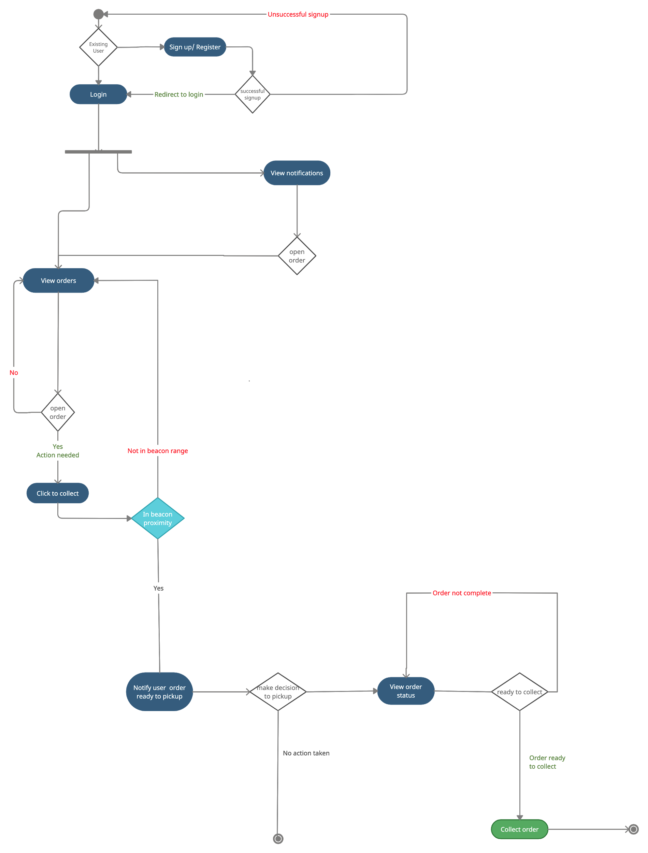

# UML Sequence Diagrams

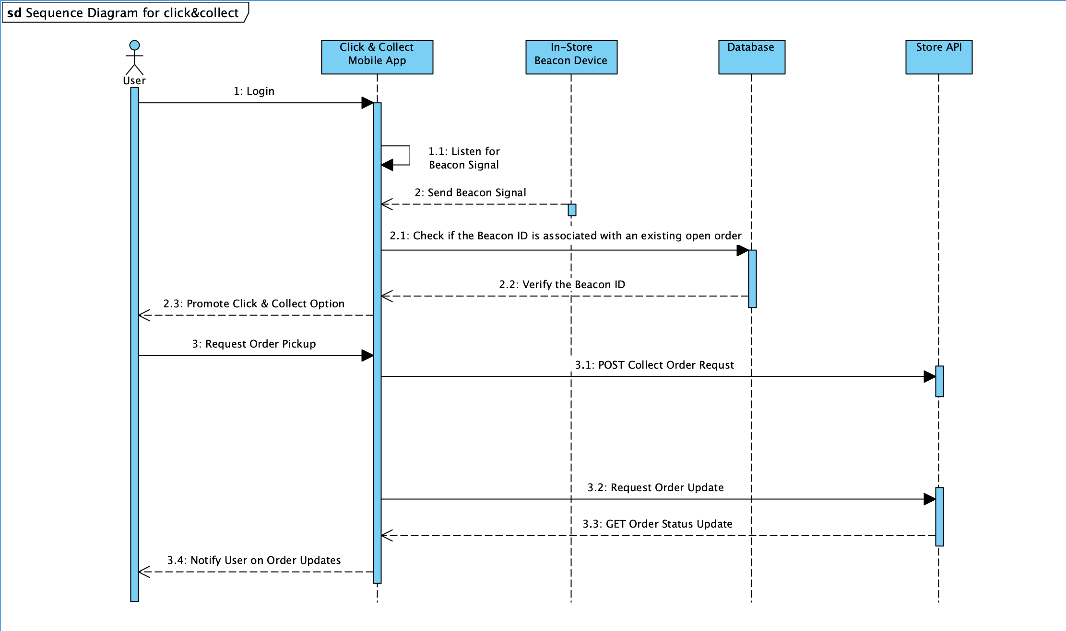

# 

# UML Collaboration Diagrams

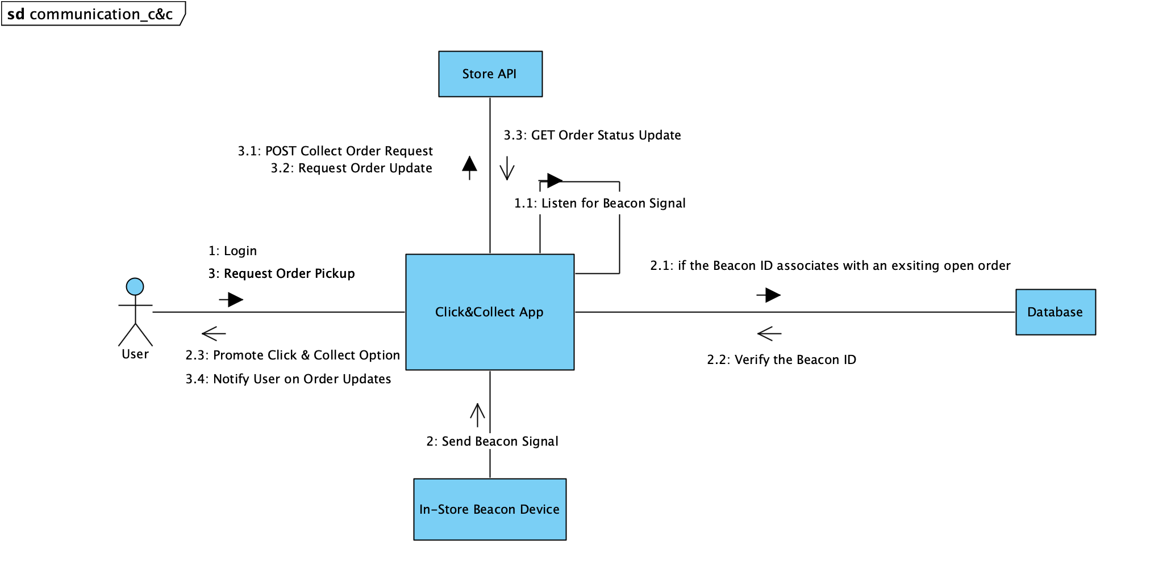

# 

# 

# UML Class diagram

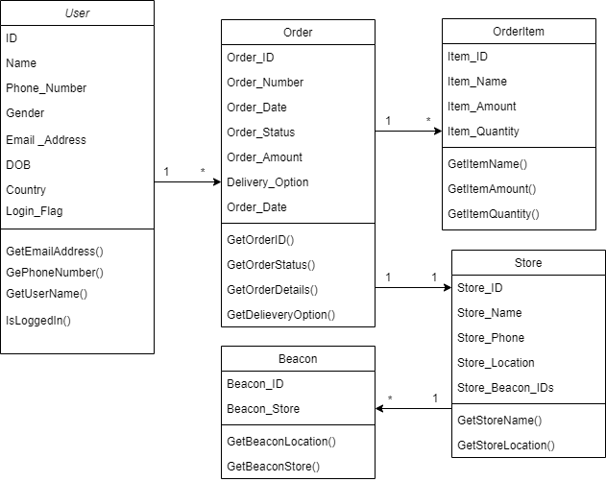

# 

# UML State Diagram

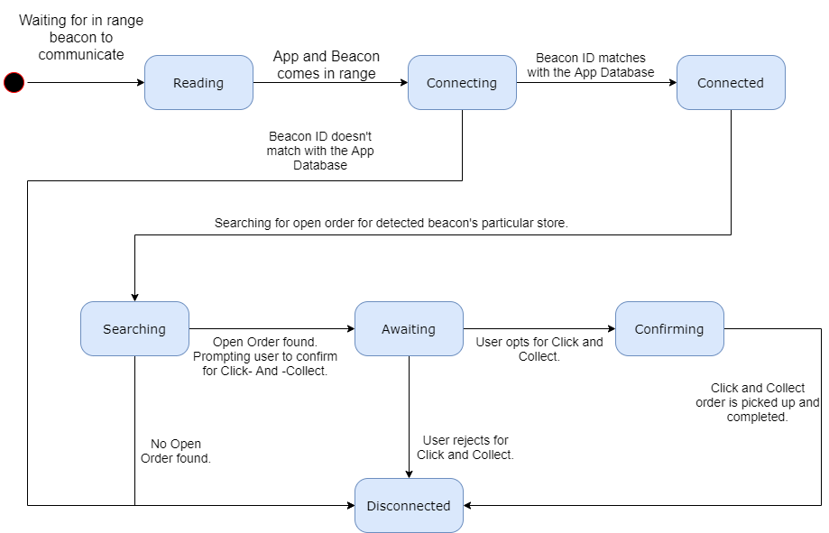

# System Component Diagram

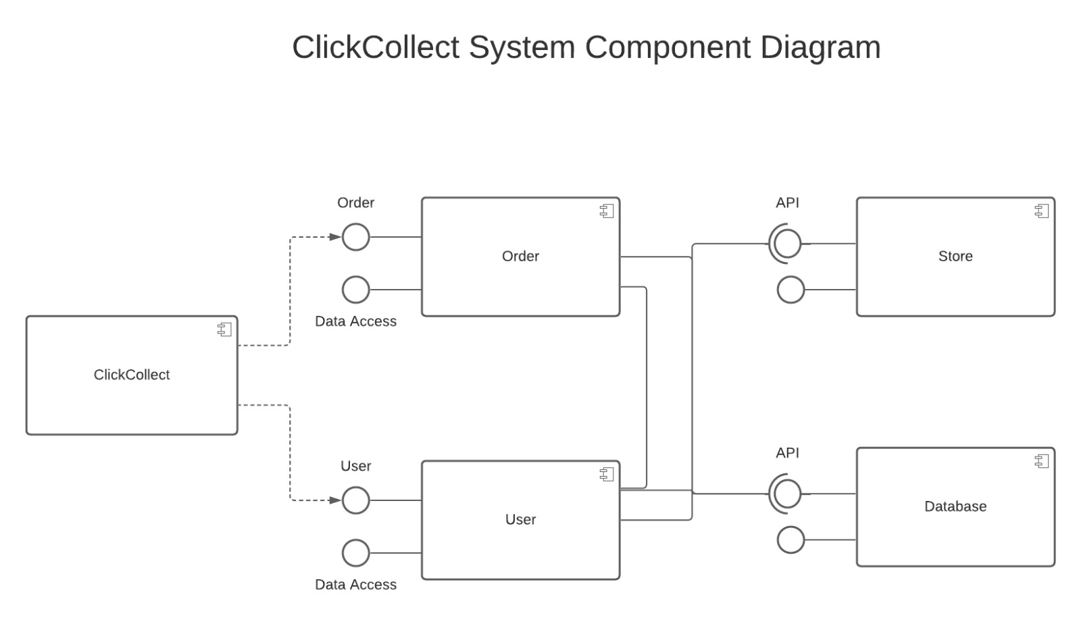

# 

# System Design Overview

# 

The Purpose of the System Design to provide how this - In-store Pickup using Beacon chips - system will be developed.The System Design Document provides a description of the system components,modules, database design, and security.

Components of the system:

* iOS Application
* Server Database
* APIs
* iBeacon devices

Modules of the system:

* Login And Registration Module
* Profile Module - Including Change Password,Edit profile details
* Notification and action on notification module
* View/Search/Filter Order module

# 

# Quality Test and Plan

1. **System Testing:** The process of testing an integrated hardware and software system to verify that the system meets its specified requirements.
2. **Regression Testing:** Type of software testing that seeks to uncover software errors after changes to the program (e.g. bug fixes or new functionality) have been made
3. **Performance Testing:** Performance Testing is a type of testing to ensure software applications will perform well under their expected workload.

|  |  |  |  |
| --- | --- | --- | --- |
| **Test case ID** | **TC1** | **Related Use Case ID** | **UC1** |
| Title | Registration to the application | | |
| Status | Pass/Fail | Priority | 2 |
| Assignee | Test Engineer 1 | | |
| Description | By entering a valid email address and a valid password, the user will get registered to the application | | |
| Input Data | First name  Last name  Email address  Password  Confirm password  Phone number  Terms of use  Submit | | |
| Testing procedure | | 1. Enter a valid first name 2. Enter valid last name 3. Enter valid email address 4. Enter password 5. Enter confirm password 6. Enter phone number 7. Accept terms of use 8. Submit registration form | |
| Expected Result | | Pass scenario: | |
| Allows access to the system if input data is valid | | * when input data is valid * when the input is provided for all required fields * when the password meets the requirement * when the email address is not registered with the system | |
| Expected Result | | Fail scenario: | |
| Does not allow access to the system | | * when input data is invalid * when the input is not provided for all required fields * when the password does not meet the requirement * when the email address is already registered with the system | |

|  |  |  |  |
| --- | --- | --- | --- |
| **Test case ID** | **TC2** | **Related Use Case ID** | **UC2** |
| Title | Log in to the application | | |
| Status | Pass/Fail | Priority | 2 |
| Assignee | Test Engineer 1 | | |
| Description | Registered user can log in to the system with valid credentials | | |
| Input Data | Email address  Password | | |
| Testing procedure | | 1. Enter Email Address 2. Enter Password 3. Submit | |
| Expected Result | | Pass scenario: | |
| Allow access to the system and navigates the user to the dashboard after validation | | * When the user enters a registered email address * When the user enters a valid password | |
| Expected Result | | Fail scenario: | |
| Does not allow access to log in and shows an error message | | * When the user enters an invalid email address * When the user enters an invalid password * When the user reaches the maximum number of try to submit a password (4 times) | |

|  |  |  |  |
| --- | --- | --- | --- |
| **Test case ID** | **TC3** | **Related Use Case ID** | **n/a** |
| Title | View orders for connected Stores | | |
| Status | Pass/Fail | Priority | 1 |
| Assignee | Test Engineer 1 | | |
| Description | User can view all orders fetched from API calls | | |
| Input Data | Request response for Get API | | |
| Testing procedure | | 1. Verify API connection for the stores 2. Validate Get call | |
| Expected Result | | Pass scenario: | |
| Show list of orders provided by API calls | | * User will see a list of orders from the stores (for instance Macy’s, Walmart, etc. for which we have access to API) for the registered email address * User will see order details, order number, order status, data when order placed, items placed, quality, amount, delivery option, pickup location) * User can perform further functionality once orders are displayed from store APIs by Get call | |
| Expected Result | | Fail scenario: | |
| Do not display the list of orders | | * When the application cannot perform API calls, a list of the order will not be displayed * When the user is not registered with the same address as the registered email address to the stores, the order will not be displayed | |

|  |  |  |  |
| --- | --- | --- | --- |
| **Test case ID** | **TC4** | **Related Use Case ID** | **UC11, UC12** |
| Title | Click and collect option for the open orders when the user is in Beacon proximity | | |
| Status | Pass/Fail | Priority | 1 |
| Assignee | Test Engineer 1 | | |
| Description | When a user is in range of beacon associated with the nearby store and has open order in the same store, the user will be notified, and click and collect option will be provided to pick up the order | | |
| Input Data | n/a | | |
| Testing procedure | | 1. Verify for open order when valid user is in beacon range - click and collect will be visible 2. Verify for open order when invalid user is in beacon range - no action 3. Verify when no open orders seen when user is in beacon range - no action 4. Verify when no open orders and user is not in beacon range - no action | |
| Expected Result | | Pass scenario(s): | |
| When in beacon proximity user will be notified for open order and Click & Collect option will be displayed for that order | | * When in beacon proximity, the beacon will identify the user email address and corresponding open orders & will provide an option to click and collect * When in beacon proximity and not a valid user, the application will not notify or provide a click and collect option * When in beacon proximity and is a valid user with no open orders, the user will not be notified to click and collect | |
| Expected Result | | Fail scenario: | |
|  | | * When in beacon proximity and not a valid user, the application will not perform any functionality * When in beacon proximity and not the correct store, the application will not perform any functionality | |

|  |  |  |  |
| --- | --- | --- | --- |
| **Test case ID** | **TC5** | **Related Use Case ID** | **UC9** |
| Title | Order status update | | |
| Status | Pass/Fail | Priority | 1 |
| Assignee | Test Engineer 1 | | |
| Description | User will be notified when order status is updated after click or collect is initiated | | |
| Input Data | n/a | | |
| Testing procedure | | No steps involved | |
| Expected Result | | Pass scenario: | |
| User should be able to see updated status once click or collect is initiated | | * Order status will be updated once click and collect is initiated * Status will updated to ‘Ready to Pickup’ from ‘Opted for Click and collect’ * Once order is pickup up, status will be updated to ‘Order complete’   Note: order status will be updated from the api call | |
| Expected Result | | Fail scenario: | |
|  | | * For the orders which are not open, should not be able to change status to ‘Opted for Click and collect’ | |

|  |  |  |  |
| --- | --- | --- | --- |
| **Test case ID** | **TC6** | **Related Use Case ID** | **6** |
| Title | Search orders | | |
| Status | Pass/Fail | Priority | 2 |
| Assignee | Test Engineer 1 | | |
| Description | User shall be able to search orders if entered keywords matches | | |
| Input Data | 1. Enter search keyword 2. Click search option | | |
| Testing procedure | |  | |
| Expected Result | | Pass scenario: | |
| The search is completed and a list of search results will be shown at the same page. | | * If entered keyword matches with the order item, name list of orders will be displayed * A list of matching orders will be shown at the same screen which includes order number, order store, order date, order status. | |
| Expected Result | | Fail scenario: | |
|  | | * No record matches the search key word, system shows a message indicating no record found. * Search time exceed the maximum search time, system shows a message | |

# 

# End user Training

1. Install the App in your iphone/iPad OS device.
2. Open the App
3. You should see buttons to login or sign up.
4. Click on the sign up button.
5. You will see a form to enter information like name, email and password.
6. Enter the details and click on create account.
7. After you log in you will see a list of orders you have placed.
8. You can click on each order and see the details and status of the order.
9. For open orders you will see a collect button.
10. You can click on the collect button to send notification to the store that you are willing to pick up your order.
11. You will get a notification from the store when the order is ready.
12. After you pick up the order the order status will get updated in the App.

# 

# References

<https://www.linkedin.com/pulse/using-beacons-better-in-store-customer-experience-greg-henry/>

<http://collectec.com/beacon-click-and-collect/>

<https://blog.beaconstac.com/2016/01/creating-a-beacon-campaign-for-your-supermarket-using-beaconstac/>

<https://www.appdynamics.com/blog/product/beacon-technology-everything-you-need-to-know-to-start-coding/>

<https://docs.gluonhq.com/samples/beacons/>

<https://reqexperts.com/wp-content/uploads/2015/07/writing_good_requirements.htm>

<https://www.researchgate.net/publication/284173600_Guidelines_for_Good_Requirements_Writing_with_Examples>

<https://clearbridgemobile.com/how-to-build-a-mobile-app-requirements-document/>

<https://www.javatpoint.com/software-engineering-software-reliability-metrics>

<https://developer.apple.com/ibeacon/>

# 

# Project Glossary

|  |  |
| --- | --- |
| API | Application Programming Interface |
| UML | Unified Modelling Language |
| iBeacon | an iBeacon is a Bluetooth low energy device emitting data following a strict format, that being an Apple-defined iBeacon prefix, followed by a variable UUID |
| ROCOF | Rate of change of frequency |
| BLE | Bluetooth low energy |
| SDK | Software Development Kit |
| iOS | iPhone Operating System |
| RE | Risk Exposure |
| RMMM | Risk Mitigation, Monitoring and Management |
| QA | Quality Assurance/Analyst |
| BA | Business Analyst |
| TLS | Transport Layer Security |
| HTTPS | HyperText Transfer Protocol Secure |
| HTTP | HyperText Transfer Protocol |
| URL | Unified Resource Locator |
| RBAC | Role-Based Access Control |
| ID | Identifier |
| REST API | REpresentational State Transfer Application Programming Interface |
| mTLS | Mutual Transport Layer Security |
| AWS KMS | AWS Key Management Service |
| SSL | Secure Socket Layer |
| IoT | Internet Of Things |
| TC | Test Case |
| UC | Use Case |